1)What is main driving force to develop ANN?
2)What is epochs?
3)What is the batch size?
4)What is the difference between Deep Learning and Artificial Neural Networks?
5)What is the difference between Forward Propagation and Backward Propagation?
6)Explain the working of a Perceptron
7)Explain why the Initialization process of weights and bias is important for NN?
8)How would you prevent Overfitting when designing an Artificial Neural Network?
9)What are some advantages of using Multilayer Perceptron over a Single-layer Perceptron?
10)Why does an artificial Neural Network use Backpropagation?

1)ANN was inspired from human neuron
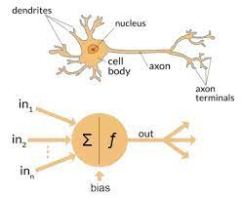
2)One Epoch is an ENTIRE dataset is passed forwards and backwards through the neural network.Since one epoch is too large to feed to the computer at once, we divide it into several smaller batches.We always use more than one Epoch because one epoch leads to underfitting. As the number of epochs increases, several times the weight are changed in the neural network and the curve goes from underfitting up to optimal to overfitting curve.

3)The total number of training and examples present in a single batch.Unlike the learning rate hyperparameter where its value doesn’t affect computational time, the batch sizes must be examined in conjunctions with the execution time of training. The batch size is limited byhardware’s memory, while the learning rate is not. Leslie recommends using a batch size that fits in hardware’s memory and enables using larger learning rate.If our server has multiple GPUs, the total batch size is the batch size on a GPU multiplied by the numbers of GPU. If the architectures are small or your hardware permits very large batch sizes, then you might compare the performance of different batch sizes. Also, recall that small batch sizes add regularization while large batch sizes add less, so utilize this while balancing the proper amount of regularization. It is often better to use large batch sizes so a larger learning rate can be used.
Dropout is implemented per-layer in a neural network.It can be used with most types of layers, such as dense fully connected layers, convolutional layers, and recurrent layers such as the long short-term memory network layer.Dropout may be implemented on any or all hidden layers in the network as well as the visible or input layer. It is not used on the output layer.
Benefits:-
1. Dropout forces a neural network to learn more robust features that are very useful in conjunction with different random subsets of the other neurons.
2. Dropout generally doubles the number of iterations required to converge. However, the training time for each epoch is less.
4)When researchers started to create large artificial neural networks, they started to use the word deep to refer to them.
- As the term deep learning started to be used, it is generally understood that it stands for artificial neural networks which are deep as opposed to shallow artificial neural networks.
- Deep Artificial Neural Networks and Deep Learning are generally the same thing and mostly used interchangeably.

5)Forward propagation is the input data that is fed in the forward direction through the network. Each hidden layer accepts the input data, processes it as per the activation function, and passes it to the successive layer.

Back propagation is the practice of fine-tuning the weights of the neural network based on the error rate obtained from the previous epoch. Proper tuning of the weights ensures low error rates, making the model more reliable.
6)In a single layer Neural Network, a set of inputs are directly mapped to an output by using a generalized variation of a linear function. This is called a perceptron.
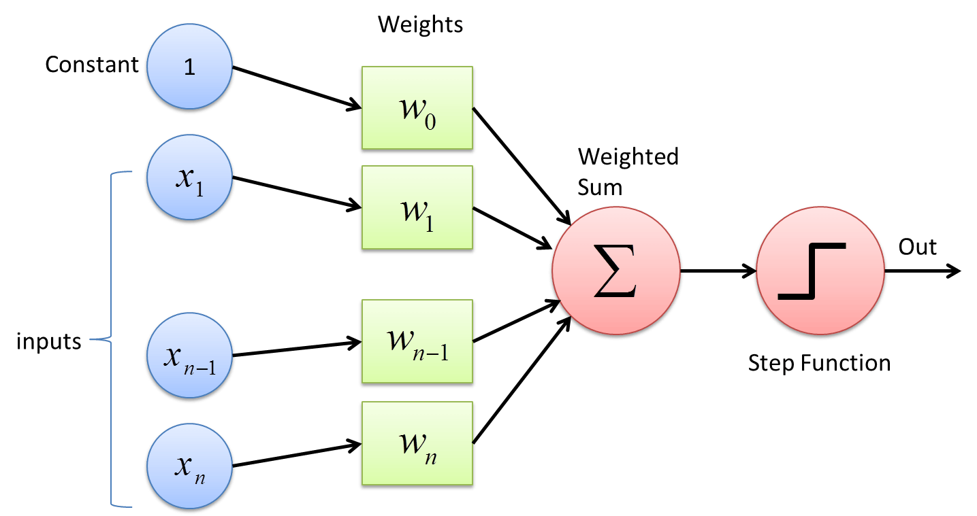
- A perceptron may be designed to give a binary class output. Historical cases for which the class variable is observed, and other cases in which the class variable has not been observed needs to be predicted.
7)The initialization step can be critical to the model's performance, and it requires the right method.
- Initializing the weights to zero leads the network to learn zero output which makes the network not learn anything.
- Initializing the weights to be too large causes the network to experience exploding gradients.
- Initializing the weights to be too small causes the network to experience vanishing gradients.
To find the perfect initialization, there are a few rules of thumb to follow:
- The mean of activations should be zero.
- The variance of activations should stay the same across every layer.

8)A model with too little capacity cannot learn the problem, but a model with too much capacity will overfit the data. To prevent overfitting the data some things that can be done are:
- Training the model in more data. Giving the model an infinite number of examples will plateau the model in terms of what the capacity of the network is capable of learning.
- Changing the network structure (number of weights). Pruning by removing the nodes in the network will counteract the overfitting.
- Changing the network parameters (values of weights). Larger weights cause sharp transitions in the activation functions and cause large changes in output for small changes in inputs. This method to keep weights small is called Regularization.
9)A multilayer perceptron is a type of neural network which has many layers of perceptron stacked on top of each other.
- Mathematically, multilayer perceptron are capable of learning any mapping function and have been proven to be a universal approximation algorithm.
- Single layer perceptron only learn linear patterns, while multilayer perceptron can learn complex relationships. This predictive capability comes from the multi-layered structure of the network, so that the features can be combined into higher-order features.
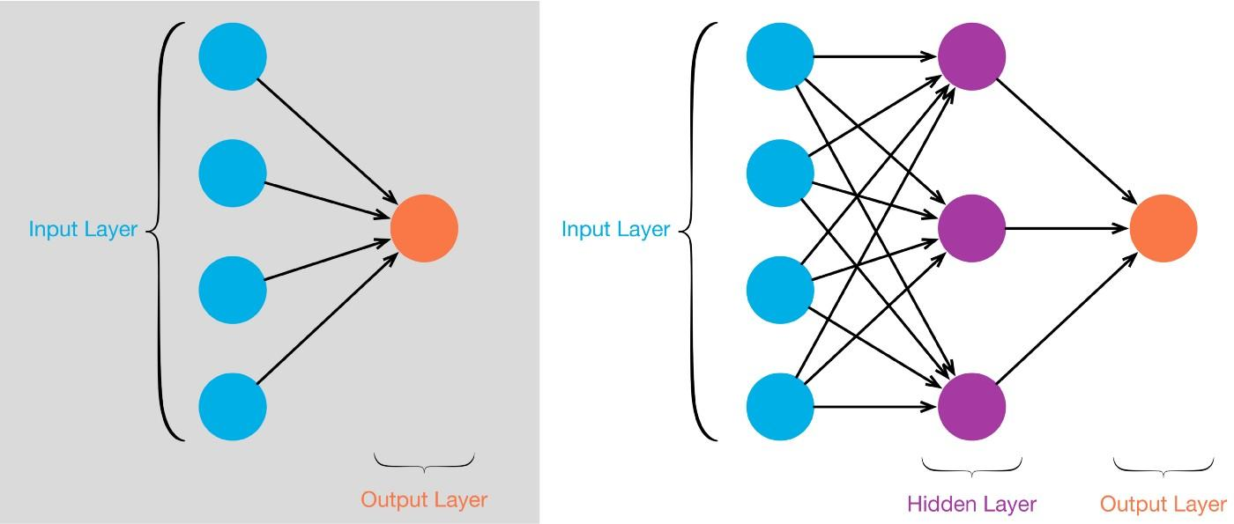

10)Backpropagation is an algorithm that computes the gradient of the loss function with respect to the weights of the network for a single input-output example.
Backpropagation only refers to the algorithm used to compute the gradient, it does not include how the gradient is used.
The formula for updating the weights and biases after calculating the gradient (the partial differentiation in the equation below) is shown below
